OO Programming Fundamentals

Practical Class 8 – Week 10th November 2014

- Create a Practical Week folder in your Java folder on your G drive

G:\Java\Practical Week 8

- Save all the following exercises into the Practical 8 folder

Exercise 1
Enter program from notes that uses a method printCompanyDetails(). You can enter it without looking at notes, if you wish. The printCompanyDetails method prints the following details to the screen every time it is called:

Create project in Practical Week 8 folder as: ex8a
Sample Output:
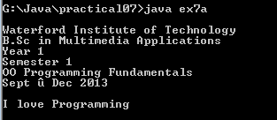

Apologies for the error in the output; the date range should read:

Sept to Dec 2014

Exercise 2
- Enter program from notes which uses a method/procedure drawStars()

Create project in Practical Week 8 folder as: ex8b1
Sample Output
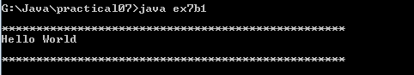

2. Edit the previous program to allow the user to enter the number of stars to be printed to the screen (in main()) by the method drawstars().

Create project in Practical Week 8 folder as: ex8b2

Sample Output


Exercise 3
Write a program which asks the use to enter a value (in main()). The value must be passed from main() to a method called square() which will calculate the square of that value and print that square value to the screen.

Create project in Practical Week 8 folder as: ex8c
Sample Output:


Exercise 4
Develop a program that uses a method called sweeteningMenu(). The program surveys users on how they like to sweeten their coffee. According to the user's menu choice each time, a message will be printed to say how the user likes to sweeten their coffee. Assume that the user can't make their mind up so answers differently each time, until they have had enough of using the program and choose to quit.

Create project in Practical Week 8 folder as: ex8d
Sample Output
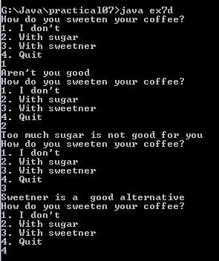

Exercise 5
- The following program uses a method called add() to calculate the sum of 2 user entered numbers.
- In main() the user is asked to enter 2 numbers.
- The numbers are stored it in 2 integer variable called num1 and num2.
- The numbers entered by the user are then passed into a method called add().
- add() calculates the sum of the numbers passed into it from main() by adding the 2 numbers together and then prints the answer to the screen.
- Nothing is returned from add() to main().

import java.util.Scanner;
public class ex7e
{

public static void main(String[] args)
{
Scanner input = new Scanner(System.in);
int num1, num2;
System.out.print("Enter a value ");
num1 = input.nextInt();
System.out.println();
System.out.print("Enter a second value ");
num2 = input.nextInt();
System.out.println();
add(num1, num2); //method call
}
// Method add()
public static void add (int a, int b)
{
int answer;
answer = a + b;
System.out.println("The sum of " + a + " plus " +b + " is " + answer);
}
}

Create project in Practical Week 8 folder as: ex8e
Enter the program.
Sample Output:
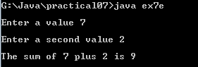

Exercise 6
Rewrite the previous program to ask the user to enter 3 numbers and store these 3 numbers in 3 variables. The 3 numbers should be passed into the method add(), where the method should add the 3 numbers and print the answer to the screen.

Create project in Practical Week 8 folder as: ex8f
Sample Output:
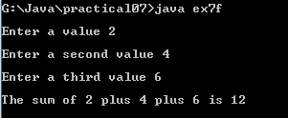

Exercise 7:
Write a program that will ask the user to enter in their age. Pass this value into a method called age(). Write the method age() to calculate whether or not they are over 18. If they are over 18 then age() should print a message telling them they can drink, otherwise print a message telling them they are too young to drink.

Create project in Practical Week 8 folder as: ex8g

Sample Output

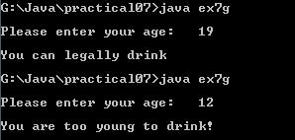

Completing this week's Practical:
- When you submit work, you will send it in zip file format.
- To create a zip file of your practical work:
  - In Windows Explorer, right click on the Practical Week 8 folder that contains your work.
  - When the context menu appears, choose the Send to option, followed by the Compressed (zipped) folder.
  - This will create a new file called Practical Week 8.zip in your current folder
- Note: If you are using your own laptop, you can choose to install very good (and free) compression software called 7zip. Just search for it in Google and download it.

*** It is this zipped file that you will upload into Moodle.***

